**ASSIGNMENT#2**

**ANSWER#2**

What will be the output in variables a, b & result after execution of the following script:

1. var a = 2, b = 1;
2. var result = --a - --b + ++b + b--;

**CODE:**

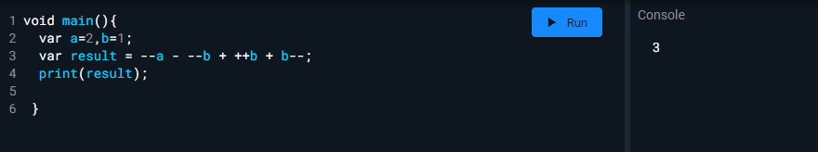

Explain the output at each stage:

1. --a;

1

1. --a - --b;

1

1. --a - --b + ++b;

2

1. --a - --b + ++b + b--;

3

**ANSWER#3**

Cost of one movie ticket is 600 PKR. Write a script to store ticket price in a variable & calculate the cost of buying 5 tickets to a movie.

**CODE:**

void main(){

var t_cost=600;

var no_of_t=5;

var total_cost=t_cost*no_of_t;

print("$total_cost Rs");

}

**OUTPUT:**



**ANSWER#4**

How to get difference of lists in Dart? Problem: Consider you have two lists [1,2,3,4,5,6,7] and [3,5,6,7,9,10]. How would you get the difference as output? E.g. [1, 2, 4].

**CODE:**

void main() {

List<double> lst1=[1,2,3,4,5,6,7];

List<double> lst2=[3,5,6,7,9,10];

List<double> difference = lst1.toSet().difference(lst2.toSet()).toList();

print(difference.toString());

**OUTPUT:**



**ANSWER#5**

What is a difference between these operators “?? And?”

**“?”:**

If condition is true, then the expression evaluates expr1 (and returns its value); otherwise, it evaluates and returns the value of expr2.

**“??”:**

If expr1 is non-null, returns its value; otherwise, evaluates and returns the value of expr2

**CODE:**

void main() {

var a=10;

var b=null;

//Example of ?

var result= a>12 ? "Condition is true":"Condition is NOT true";

print(result);

//Example of ??

var assign= b ?? a;

print(assign);

}

**OUTPUT:**

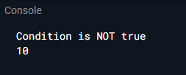

**ANSWER#6**

What are the data types supported in Dart? Explain with Examples

**CODE:**

void main() {

//String

String str="My name is Muhammad Rayyan";

print(str);

//Integer

int num1=2;

print(num1);

//Double

double num2=3.512;

print(num2);

//Num

num num3=num1+num2;

print(num3);

//Bool

String a="Rayyan";

String b="Anas";

bool ans = (a==b);

print(ans);

String c="Rayyan";

String d="Rayyan";

bool ans2 = (c==d);

print(ans2);

//List

var lst = List<int>.generate(4, (i) => i + 1);

print(lst);

//Map

Map student = {'name':'Tom','age': 23};

print(student.values);

}

**OUTPUT:**

